**POWER BI**

**AND**

**TABLEAU ONLINE**

**Assignment-1**

**Submitted By :-**

**Sachin Kumar**

**Task 1 :- Install Power BI Desktop and share the final screenshot of the report view page which appears when power desktop starts.**

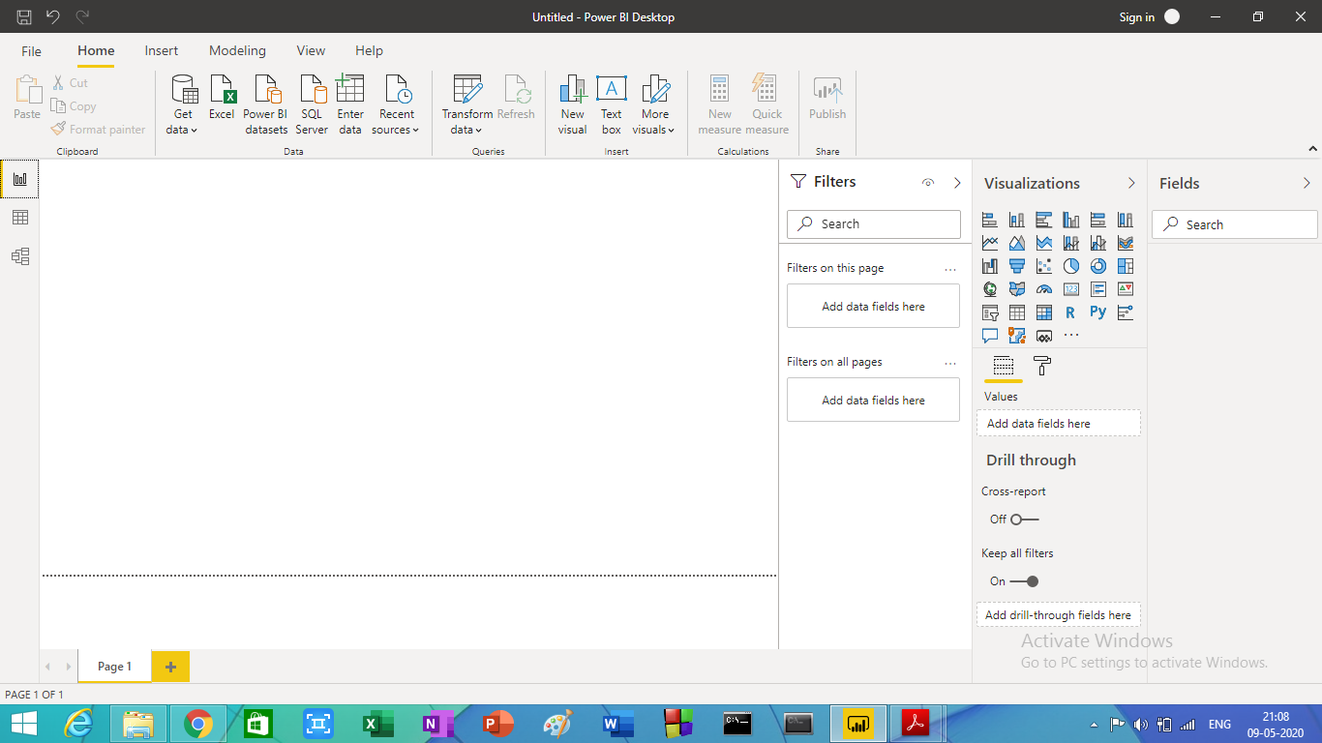

**Image- Report View page**

Task 2:- Prepare a document and with the following screenshot

Report View

Data View

Model View

Power Query Editor

Advanced Power Query Editor

* −Report View

Report view, where you can create any number of report pages with visualizations. When you first load data in Power BI Desktop, you'll see the Report view with a blank canvas. A report will have at least one blank page to start. Pages appear in the navigator pane just to the left of the canvas. You can add all sorts of visualizations to a page.

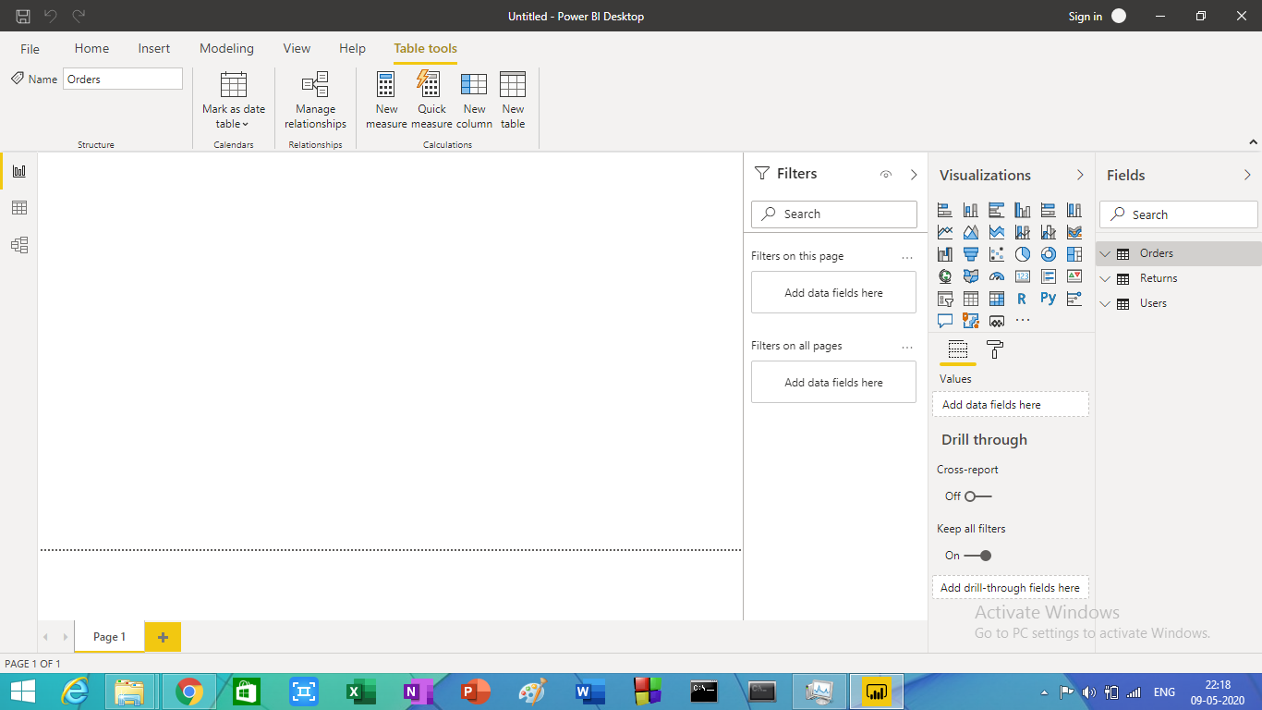

* − Data View

Data view helps you inspect, explore, and understand data in your Power BI Desktop model. When you're modelling your data, sometimes you want to see what's actually in a table or column without creating a visual on the report canvas. You might want to see right down to the row level. This ability is especially useful when you're creating measures and calculated columns, or you need to identify a data type or data category.

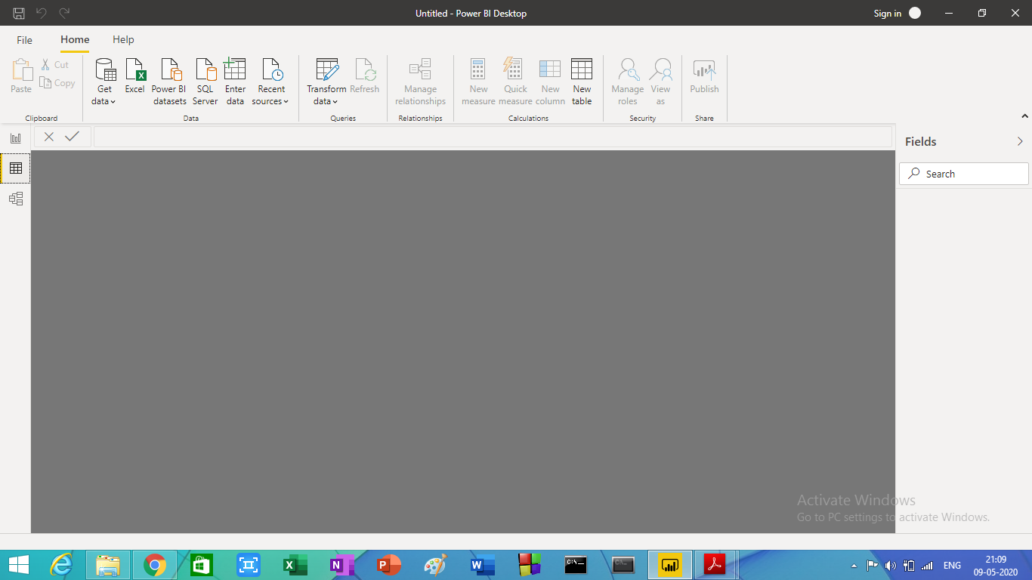

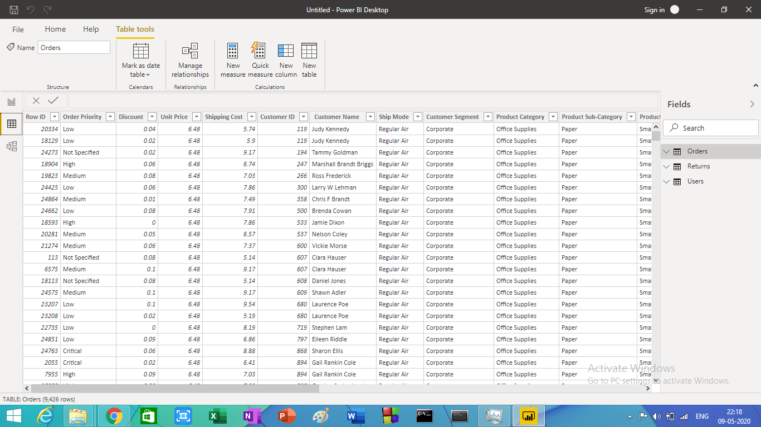

* − Model View

Model view shows all of the tables, columns, and relationships in your model. This view can be especially helpful when your model has complex relationships between many tables. Select the **Model** icon near the side of the window to see a view of the existing model. Hover your cursor over a relationship line to show the columns that are used.

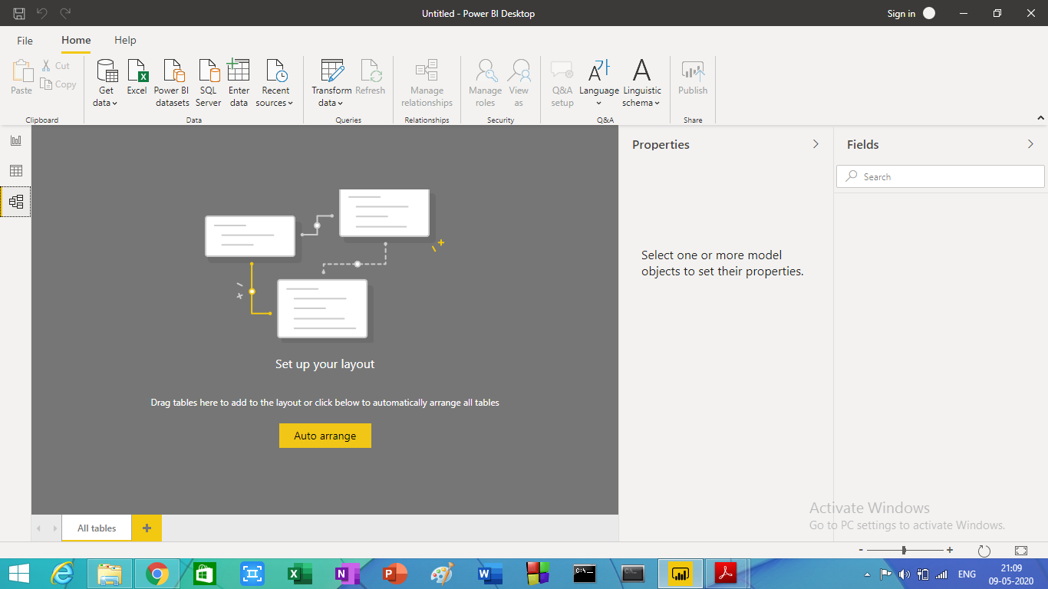

* − Power Query Editor

With Power Query in Power BI you can connect to many different data sources, transform the data into the shape you want, and quickly be ready to create reports and insights. When using Power BI Desktop, Power Query functionality is provided in the Power Query Editor.

In power query editor we can perform common data transformation tasks, such as adding or removing columns or rows, changing data types, splitting columns, and other data-driven tasks etc.

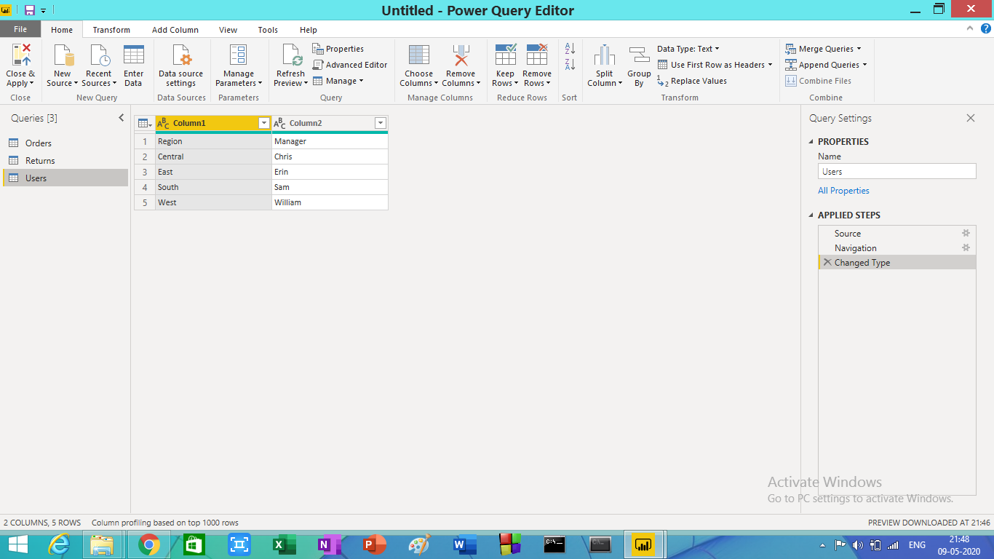

* − Advance Editor

The Advanced Editor lets you see the code that Power Query Editor is creating with each step. It also lets you create your own shaping code. To launch the advanced editor, select View from the ribbon, then select Advanced Editor. A window appears, showing the existing query code.

You can directly edit the code in the **Advanced Editor** window.

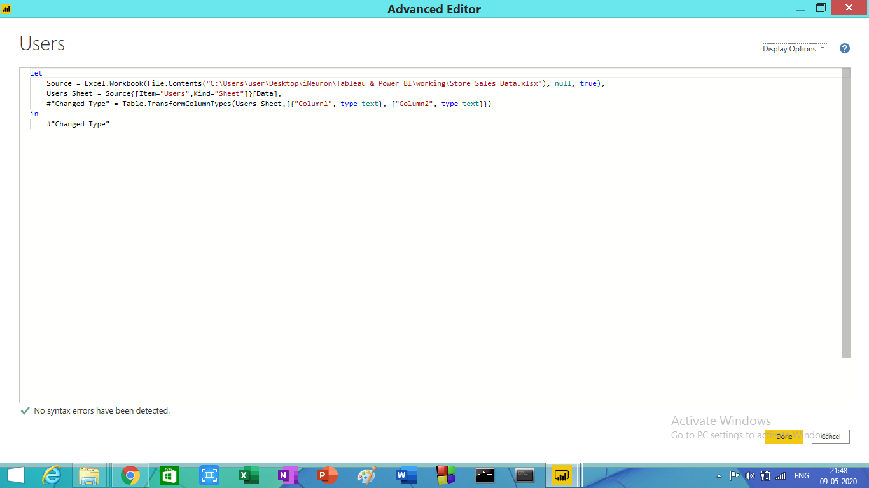

Task 3:- Prepare a document with details of the following along with their price

* Power BI Desktop
* Power BI Pro
* Power BI Premium

**Power BI Desktop** :- Power BI Desktop is the free version of Power BI that you can install on your local computer as a program, and acts as a companion desktop application to the full version of Power BI. If you need to consolidate your data sources, create your own reports and conduct your own analysis or test it’s capabilities, it’s the perfect version to start with for all skill levels - whether you’re non-IT and want to make your reports more interactive, or analysts seeking richer detail, it's one of the best business analytics tools to use.

You can explore your data, automatically find patterns, understand what your data means, and predict future outcomes to drive business results.

Despite of its free nature, Microsoft has included with Power BI Desktop:

* You can connect and import data from over 70 cloud-based and on-premises sources.
* The same rich visualisations and filters from Power BI Pro.
* Auto-detect that finds and creates data relationships between tables and formats.
* Export your reports to CSV, Microsoft Excel, Microsoft PowerPoint and PDF.
* Save, upload and publish your reports to the Web and the full Power BI service.
* Storage limit of 10 GB per user.

Naturally, there are some feature limitations with the free Power BI Desktop that give further incentive to upgrade.

* Can’t share created reports with non-Power BI Pro users,
* No App Workspaces.
* No API embedding.
* No email subscriptions.

**Power BI Desktop Price**- It is free to use.

**Power BI Pro** :- Power Bi Pro is the full version of Power BI, complete with the ability to use Power BI for both building dashboards and reports and unlimited viewing, sharing and consumption of your created reports (and reports shared by others) - the latter not possible with Power BI Desktop.

A breakdown of Power BI Pro’s differences against Power BI Desktop:

* Ability to embed Power BI visuals into apps (PowerApps, SharePoint, Teams, etc)
* Native integration with other Microsoft solutions (Azure Data Services)
* Share datasets, dashboards and reports with other Power BI Pro users
* Can create App Workspaces and peer-to-peer sharing.
* 1GB Maximum size of individual dataset.

Power BI Pro is licensed by individual user. For example, if your organisation has 20 people that need to full capabilities of self-service BI to create dashboards and reports, you need 20 licenses of Power BI Pro, which gives these users full access to creation of reports and unlimited consumption (viewing) of any created content.

If you have a lot of users, Power BI Pro can obviously become quite expensive. but there’s a better option if you have more users that need to consume reports than use Power BI for creating reports, which is Power Bi Premium.

**Power BI Pro Price** :- $9.99 monthly per user

**Power BI Premium**:- Power BI Premium is the most expensive tier of Power BI currently available and very distinct from the other two versions available on the market.

On top of the features and functionality standard to all versions of the service, users of Power BI Premium get:

* Enterprise BI, bigdata analytics, cloud and on-premises reporting.
* Advanced administration and deployment control.
* Dedicated cloud compute and storage resources.
* Allow any user to consume Power BI content.
* Increased data capacity limits and maximum performance.
* Access to one API surface.
* Store Power BI data to Azure Data Lake Storage.
* Ability to embed Power BI visuals into apps (PowerApps, SharePoint, Teams, etc).
* Larger storage sizes for extended deployments.
* Geo distribution, higher refresh rates, isolation, pin to memory, read-only replicas.
* Power BI Report Server.
* AI-powered data modeling using AutoML, Cognitive Services, and Azure Machine Learning.
* 10GB Maximum size of individual dataset.

Power BI Premium differs from the free version and Power BI pro in its licensing model, which only suits a specific size and type of organisation and business scenario. You can purchase Premium in a range of capacity sizes that offer different numbers of memory and virtual cores that can scale as your data analysis requirements change.

With Power BI Premium, you are licensing capacity for your datasets, dashboards and reports, not just licensing all users of that content. In other words, you’re not buying individual licenses, you’re buying them in bulk to allow a large number of your users to use Power BI to view reports. All of your content is stored in Premium and can then be viewed by as many users in your organisation as you want, without additional per-user costs.

**Power BI Premium Price**:- $4,995 monthly price per dedicated cloud compute and storage resources with annual subscription.

---------------------------------------------------------------------------------------------------------